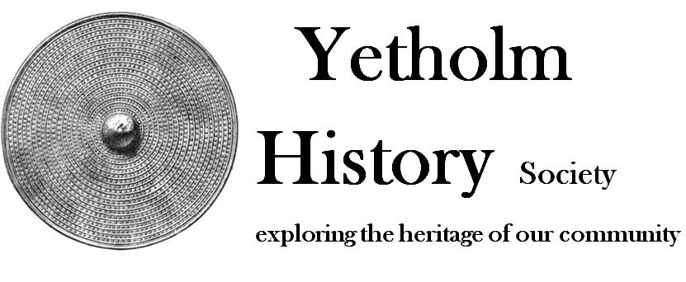

Statement in support of grant application

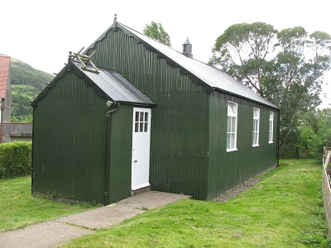
The old Mission Hall in Town Yetholm
Yetholm History Society
Please see our Business Plan for more about Yetholm and the Society.

Context
Yetholm is close to the edge of the Cheviots in the Scottish Borders. The area has a rich history. Yetholm History Society is active in the local community: we produce leaflets, books and DVDs; put on annual exhibitions; keep a website; record the memories of older inhabitants; and organise a programme of talks and outings. We have catalogued our extensive archive and digitised all our photographic material.

We are a charity run by local volunteers. Board members are active and committed. We manage our funds carefully. We have raised money from our publications and from local charities and other organisations. We have ring-fenced a sum towards the conservation of the archive. Local people trust us with their contributions to the archive. The Society is a point of contact for people wanting information about ancestors from Yetholm.

In 2015 we were gifted a ‘tin tabernacle’, a disused Mission Hall, which we have conserved. We are developing it as an archive and heritage centre as well as the hub for the Society. Our archive needs museum-quality safe storage. We want to make sure that our members are warm, safe and comfortable both inside the Mission Hall and on their way to and from the hall, and that they can easily hear and see presentations. Our programme of talks takes place in the dark winter months.

We plan to equip the Hall with display panels and to open it to tourists visiting this part of the Borders, so that they can learn about the special archaeology and history of the area. As part of this we will also include display panels, stands and display cases in Yetholm Kirk, illustrating its long history.

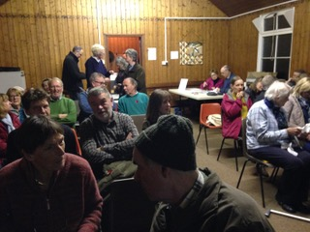

Visitor Numbers

Yetholm History Society currently has 63 members. We have six talks a year from visiting speakers: average attendance at these is 50 people. There are about 100 visitors to our annual exhibition. This makes a current total of about 400 visits a year to the Mission Hall.
There are about 1,000 visitors to the village each year, and we expect that about half of these would visit an improved Heritage Centre, making a potential total of 900 visits a year.

Our plan for the Mission Hall

The plan is in three sections. We are initially seeking funding for developing and equipping the interior of the Mission Hall.
Please see next sheet for details and estimated costs.

CONSERVING AND HEATING THE MISSION HALL

This phase is now complete. It included repairing and painting the exterior of the Hall and replacing its inadequate heating. We achieved this through the use of volunteer labour, a bequest, funding from a local charity and a Community Grant of £1813.

DEVELOPING AND EQUIPPING THE INTERIOR OF THE MISSION HALL

- Archive
Our valuable archive of documents, photographs, audio recordings and artefacts needs lockable fire-proof storage.
- Display
Topics for the illustrated display panels will include: the Bronze Age and the famous Yetholm shields; the Reivers in the 16th century; the weaving industry in the 18th century; and the story of the gypsies of Kirk Yetholm. We need lockable display cabinets in the Hall and in the Kirk. We also need display stands for remnants of the 12th century stone Kirk.
- Audio-visual equipment
Our current arrangements are cumbersome and inadequate. Permanently fixed equipment is necessary if we are to open the Hall to the public.
- Lighting, chairs, carpeting
The present strip lighting should be replaced with dimmable overhead lighting and spot lighting for the display panels. At the moment, the plastic chairs we have are uncomfortable and unsuitable for those with mobility problems. We have inherited flimsy unfixed carpet tiles, which need replacing with safer carpeting.

DISABLED ACCESS AND FIRE EXIT

Exterior work: we intend to insert a second door in the side of the Hall, with a ramp for wheelchair access. This door will also serve as a fire exit. The entrance path will be relocated and properly lit. We are still in the position of commissioning architectural drawings and obtaining planning permission for this work. We intend to seek funding for this section of the project for 2019/20. As part of this work, there will be a lockable exterior notice board at the entrance and signs to the Hall in the village.

SUPPORT FROM THE COMMUNITY AND OUR MEMBERSHIP
We have received grants from local organisations, which show support from the wider community. These are: Charity Begins at Home, a Kelso charity; The Windfall Fund which sells spare apples collected locally; and the North Northumberland National Park.

Our members and the people of Yetholm are pleased that the Old Mission hall has been rescued and is being put to good use. Members and visitors approve of the work we have carried out so far. We have displayed our plans for disabled access. The Community Council has agreed to host our application for planning permission.

Elements | Estimated costs  (including installation costs) | Notes
CONSERVING AND HEATING THE MISSION HALL
Completed August 2018
DEVELOPING AND EQUIPPING THE INTERIOR OF THE MISSION HALL
Archive materials and fire-proof cupboards | £3000;  £1300 from funds; £1700 shortfall | Museum quality storage and acid-free boxes and folders.
Display panels: illustrations; manufacture | £5000 | 8 in the Hall and 3 in the Kirk
Stands | £600 | For the Kirk
Display cabinets | £1200 | 2 in the Hall and 1 in the Kirk
Projector and electric screen | £2500 | Projector to be ceiling-mounted
Audio loop and loudspeakers | £1500
Lighting | £1000
Chairs | £2000
Carpet | £2000
SUB-TOTAL estimate | £17,500
DISABLED ACCESS AND FIRE EXIT
Fees for architect and building warrant | £1,600
Disabled access and ramp | We are in the process of applying for planning permission and building warrants for this work to take place in 2020.
Path and ground level lighting
Notice board and signs.
SUB-TOTAL estimate | £8,500
OVERALL estimate | £26,000

